

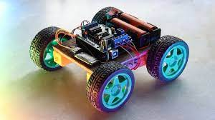

**Embedded systems: Motor Car Plan**

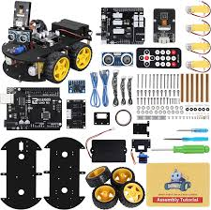

Components required:

* Arduino Uno or any compatible board
* Motor Driver L293D IC
* DC Motors x2
* Wheels x2
* Chassis or platform
* 9V Battery
* Jumper Wires
* Breadboard

Circuit Diagram:

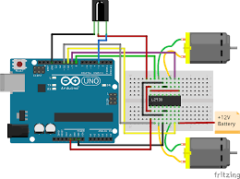

Instructions:

* Connect the L293D motor driver IC to the breadboard and the Arduino board.
* Connect the 9V battery to the breadboard, and connect the power pins of the motor driver IC to the breadboard.
* Connect the two DC motors to the motor driver IC, ensuring that the positive and negative terminals are correctly connected.
* Connect the wheels to the DC motors.
* Attach the motors and wheels to the chassis or platform, ensuring that they are securely fastened.
* Write and upload the code to the Arduino board using the Arduino IDE or any other compatible software.

Here's some sample code that you can use as a starting point: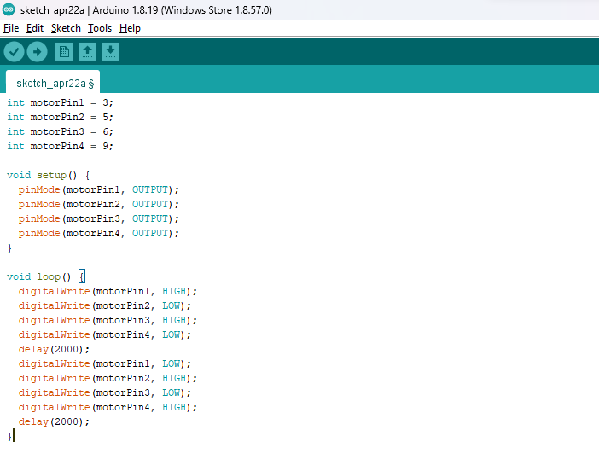

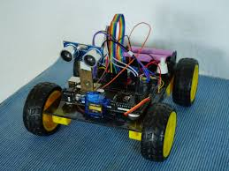

This code will make the car move forward for 2 seconds and then move backwards for 2 seconds. You can modify the code to add more functionality to the car, such as turning left or right.

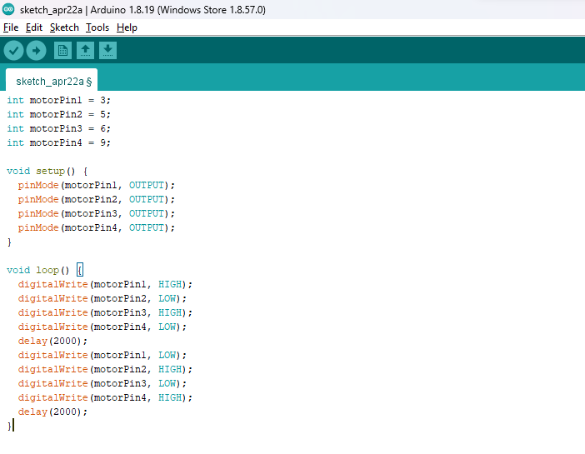

int motorPin1 = 3;

int motorPin2 = 5;

int motorPin3 = 6;

int motorPin4 = 9;

void setup() {

pinMode(motorPin1, OUTPUT);

pinMode(motorPin2, OUTPUT);

pinMode(motorPin3, OUTPUT);

pinMode(motorPin4, OUTPUT);

}

void loop() {

digitalWrite(motorPin1, HIGH);

digitalWrite(motorPin2, LOW);

digitalWrite(motorPin3, HIGH);

digitalWrite(motorPin4, LOW);

delay(2000);

digitalWrite(motorPin1, LOW);

digitalWrite(motorPin2, HIGH);

digitalWrite(motorPin3, LOW);

digitalWrite(motorPin4, HIGH);

delay(2000);

}

Here's a reference link for more information on Arduino motor car projects:

[Arduino Motor Car Project Tutorial](https://create.arduino.cc/projecthub/picklerick92/simple-arduino-controlled-motor-car-5e5e12)